R I C E FORTIFICATION I N M Y A N M A R

T A C K L I N G M I C R O N U T R I E N T M A L N U T R I T I O N
Introducing Fortified Rice in Myanmar

HIDDEN HUNGER

In Myanmar, more than one-third of children under five years old are chronically malnourished or stunted. Many are suffering from micronutrient deficiencies, which have lifelong consequences for health, productivity, and mental development. Rice is the staple food of Myanmar, but it is devoid of many necessary vitamins and minerals. Fortifying rice is an effective way to improve nutrition without requiring that people change their consumption habits, and without genetically modified substances.

A PROVEN APPROACH

Fortified rice is a culturally appropriate solution aimed at breaking the cycle of micronutrient malnutrition. Hot extrusion technology is used to combine rice flour and micronutrients—including iron, zinc, vitamin A, thiamin, folic acid, and other B vitamins. This mixture is extruded through pasta-making equipment and formed into the shape of rice grains. When these grains are blended with traditional rice, with just 1-2 fortified grains per 100 grains of regular rice, the result is fortified rice that is nearly identical to regular rice in aroma, taste, and texture.

PATH has supported the introduction of fortified rice in countries across the world, including Brazil, India and Cambodia. Working with global partners, we have developed technical standards which ensure the nutritional integrity of fortified grains throughout transport, storage, washing, rinsing, and cooking; and guarantee that the ingredients used meet international regulatory standards.

Fortified rice has proven safe and effective in pilot programs and field studies in communities with varying cultural practices and nutritional needs around the world. There is a solid evidence base of more than 30 clinical trials, acceptability and feasibility studies, and market introductions.

Photo: PATH/ Seema Kapoor
Tasting fortified rice

PROJECT GOALS

PATH’s fortified rice project in Myanmar builds on our experiences around the world. The goal is to reduce micronutrient deficiencies in the population while also creating income-generation opportunities for supply chain and distribution actors.

PUBLIC, PRIVATE AND SOCIAL SECTOR PARTNERS

- The National Nutrition Centre, housed at the Myanmar Ministry of Health, is the lead public sector partner

- The fortified rice is locally produced in Myanmar by private sector companies

- Population Services International leads on consumer demand-generation efforts

- Myanmar Business Development Consulting is coordinating outreach and distribution to retailers

- The World Food Programme, UNICEF and World Vision help guide the overall project, with particular focus on social sector distribution

December, 2015

GOVERNMENT SUPPORT

The Myanmar Ministry of Health is a strong proponent of fortified rice. Its National Nutrition Centre chairs the Myanmar Rice Fortification Working Group, with technical assistance from PATH and active participation from the public, social, and private sector partners. Together we are developing national policy recommendations for rice fortification. The goal is to ensure a supportive regulatory environment and effective quality standards.

SUPPLY CHAIN AND DISTRIBUTION CHANNELS

To support the growth of the fortified rice supply chain in Myanmar, PATH is providing technical assistance to private companies, including fortified grain producers, blender fabricators, and rice millers. We are assisting them to procure and deploy the machinery necessary for fortified rice production. Additional corporate partners will be engaged as the project expands.

Fortified rice will be distributed through both private and public sector channels. Consumers across all income levels will have access to fortified rice brands at their local markets. Women, young children and key populations such as those with HIV and tuberculosis will be reached through social safety net programs.

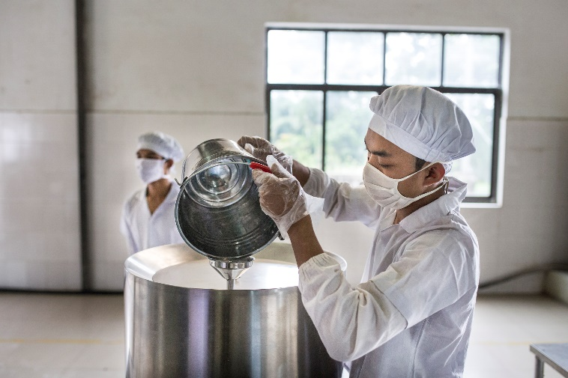
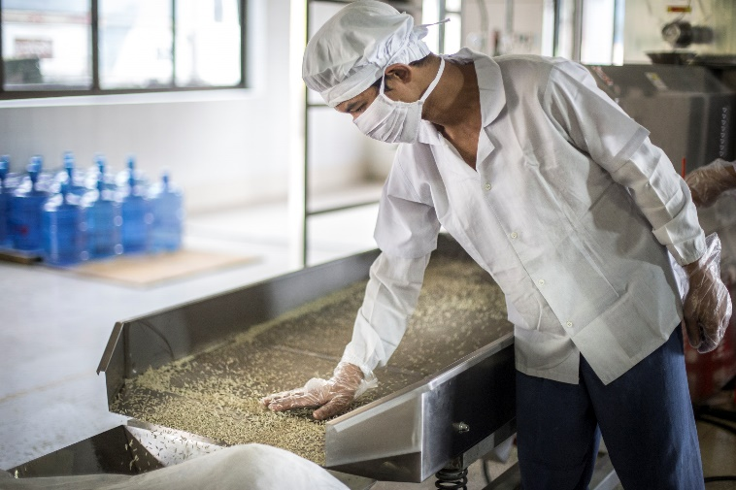
Photo: PATH/ Minzayar
Fortified rice grains rolling off the production line

A FOUNDATION FOR LASTING IMPACT

People in Myanmar are among the highest rice consumers in the world, consuming more than 300 grams per day per person. Moving the population to a fortified version of this favorite staple food has enormous potential for improving health. By creating an aspirational and affordable product that people associate with healthy living, we are creating the eco-system for a thriving private market while at the same time using social safety programs to reach vulnerable populations. This sets the stage for a future in which all rice consumed in urban and peri-urban areas in Myanmar is fortified, an achievement which would substantially reduce micro-nutrient deficiencies and improve the health of the nation.

CONTACT INFORMATION

Dr. Myo Myint Aung
PATH
Fortified Rice Project Director
amyo@path.org
Phone: (+95-1) 230 4781

Photo: PATH/ Minzayar
Preparing the pre-mix and rice flour.

Generous donor support for this project is provided by the Livelihoods and Food Security Trust Fund (LIFT), a multi-donor fund established in 2009 to improve the lives and prospects of poor and vulnerable people in rural Myanmar.

PATH is the leader in global health innovation. An international nonprofit organization, we save lives and improve health, especially among women and children. We accelerate innovation across five platforms—vaccines, drugs, diagnostics, devices, and system and service innovations—that harness our entrepreneurial insight, scientific and public health expertise, and passion for health equity. By mobilizing partners around the world, we take innovation to scale, working alongside countries primarily in Africa and Asia to tackle their greatest health needs. Together, we deliver measurable results that disrupt the cycle of poor health. Learn more at www.path.org.

Room C071-072, 7th Floor No. 131, Shwe Pyi Aye Condo Corner of Bagayar Road and ShwePyi Aye Street Sanchaung Township
Yangon 11081 Myanmar
95-01-23

